**Git pull**

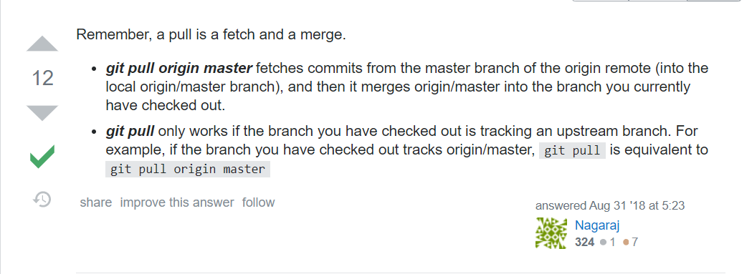

If the remote branch name and local branch name are different then Git pull works like below

**Git pull origin remoteBranchName:localBranchName**

**Git pull = Git fetch + Git merge 🡪** If we are doing Git fetch then all the changes in the remote repository branch will move to the tracking remote branch. And then later when we are ready we can commit our changes and then do a merge while on local master branch as git merge origin/master.

**Git push –u origin master 🡪** The –u option when used with the push command helps to track the master branch in local with the master branch in remote. Basically it is like setting up a link

**Git push**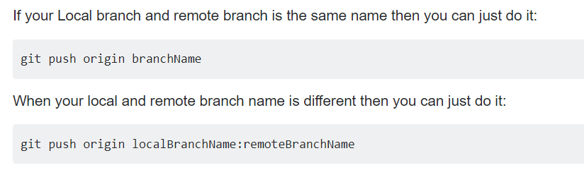

**Process of pulling from remote branch into a local branch and then later merging it with another local branch**

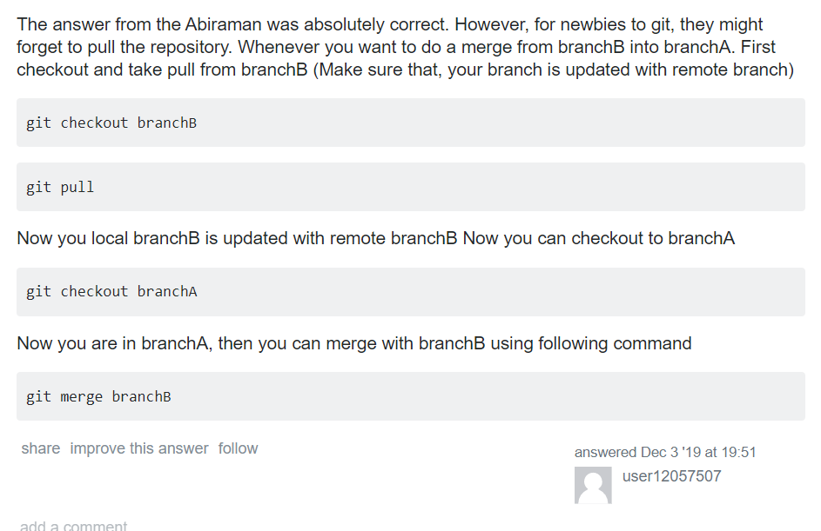

**GIT push to a remote branch after renaming the local branch**

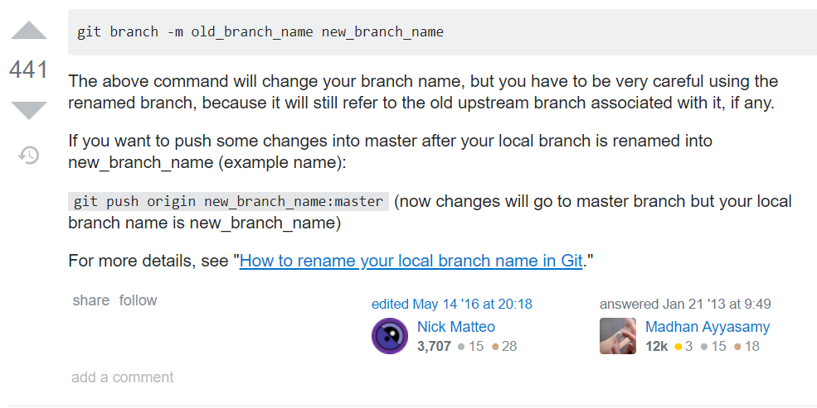

**GIT revert vs GIT reset --** <https://www.pixelstech.net/article/1549115148-git-reset-vs-git-revert>